# Nippers Handbook - 2024/25 Season

**Welcome to all our Nippers, both new members and those continuing from last season, to the Shelly Beach Nipper program for children aged 5 to 14.**

Nippers is about surf lifesaving, with a focus on having fun, teaching surf education and skills and emphasizing community awareness. The aim is to provide a safe, friendly and welcoming environment where both Nippers and parents can interact and enjoy a morning at Shelly Beach, and where hopefully in years to come, we build a future generation of Lifesavers for Shelly Beach.

At Nippers, we do not teach children how to swim, however we will teach them surf skills. In fact, one of the best features of Nippers is seeing young children gain confidence in the water. Children who are afraid of the water can develop through encouragement, education and training to be confident in the surf.

All Nippers (U6+) are strongly encouraged to undertake regular swimming training through a local Club or pool. Our Nipper program provides board training (U9+) and sand training (U8+) and competition for those Nippers who wish to join.

We encourage all parents to participate with us whether it is on the beach helping to run activities, in the water assisting with Water Safety, officiating at Carnivals or helping with the Shelly Beach BBQ. Like all volunteer organisations we are only as good as the help we get: the more help, the better it is for everyone.

We look forward to another positive and rewarding season for all.

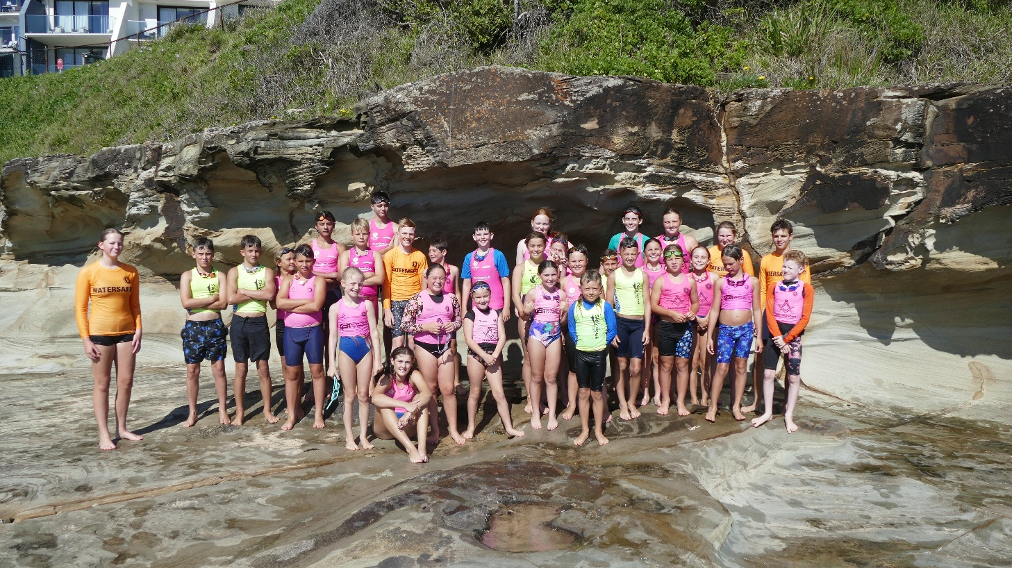

# Membership

## Who can join Nippers?

Any child may join Shelly Beach Nippers once they have turned five years old and fall within a designated SLSA Nippers age group. Nipper age groups are determined as at 30 September each year.

|  |  |  |
| --- | --- | --- |
| **AGE GROUP** | **CAP COLOUR** | **DATE OF BIRTH** |
| Under 6 |  | 01 Oct 2018 – 30 Sept 2019 |
| Under 7 |  | 01 Oct 2017 – 30 Sept 2018 |
| Under 8 |  | 01 Oct 2016 – 30 Sept 2017 |
| Under 9 |  | 01 Oct 2015 – 30 Sept 2016 |
| Under 10 |  | 01 Oct 2014 – 30 Sept 2015 |
| Under 11 |  | 01 Oct 2013 – 30 Sept 2014 |
| Under 12 |  | 01 Oct 2012 – 30 Sept 2013 |
| Under 13 |  | 01 Oct 2011 – 30 Sept 2012 |
| Under 14 |  | 01 Oct 2010 – 30 Sept 2011 |

**Nippers age groups are strict:** the SLSA system does not permit movement up or down an age group.

## Registration

All registrations and renewals can be made online via a centralised SLSA system or we encourage you to head down to Shelly Beach Surf Club on registration dates to register.

New members must send a copy of proof of age document (birth certificate or passport) to or bring it to the Club to be sighted by the office - <https://shellybeachsurfclub.com.au/get-involved/.>

If you are renewing your membership or transferring your membership from another surf club, you’ll need to do so via your ‘SLS Members Area Account’ (established when you first joined Shelly Beach or any SLSA Club) here - <https://members.sls.com.au/SLSA_Online/modules/login/index.php.>

## Fees for 2024/25 season:

When you join or renew your membership, you will be prompted to pay the season’s fees.

No membership will be accepted without payment.

Shelly Beach SLSC is part of the "Active Kids" program where you can take advantage of the $50.00 rebate offered by the NSW Government.

Unfortunately, Active Kids vouchers are not able to be redeemed when renewing online this year and need to be processed manually. These can be forwarded directly to our Registrar and the amount deducted from the Registration fee.

We require one parent / guardian to be a member of the Club, together with their Nipper/s. You’re welcome to purchase additional parent memberships if you wish. Any parent who volunteers as an Age Manager, Age Assistant, Water Safety or Official needs to be a member.

|  |  |
| --- | --- |
| **NIPPERS MEMBERSHIP** | |
| Family of one | $110 |
| Family of two | $215 |
| Family of three | $310 |
| Family of four | $370 |
| Family of five or more | $400 |
| Returning Active Patrolling Member | $55 |

***Note:***  
***Any members who have not turned 15 prior to 1/10/24 are required to have a parent/guardian join as well.***

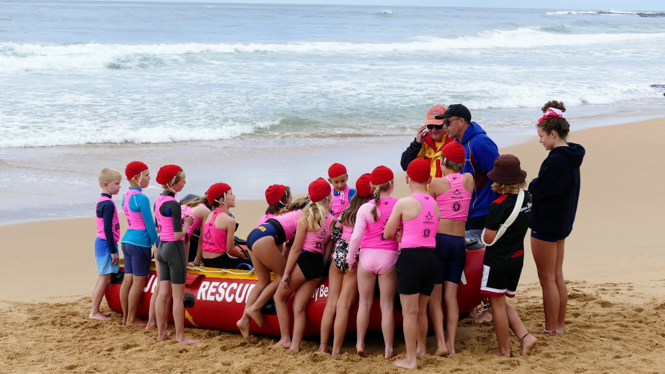

# Sundays at Nippers

## Communication – Facebook

We primarily use Facebook for Nippers communications. Please request access to ‘[Shelly Beach Nippers](https://www.facebook.com/groups/2430938077141107)’. Every nipper parent should join in order to keep abreast of Nippers News and any last-minute alerts (for e.g., cancellations).

## Start Time: 9:00 am

ALL Nippers need to be signed into and out of Nippers and it is the responsibility of parents to ensure this happens every week. Please arrive early so that Nippers can be marked off by their Age Managers and the session can start on time.

It is a safety requirement that all Nippers remain with their age group for the full duration of Sunday Nippers. At the end of the session, every Nipper needs to be signed out before leaving with a parent or guardian. If a child needs to leave early, the parent/guardian must arrange to sign them out with their respective Age Manager.

## What to bring:

There are 2 compulsory items that every Nipper must wear:

1. their Shelly Beach Age Cap*; and
2. their High-Vis rash vest *compulsory for all nippers.

These are safety requirements so that all Nippers are easily observable on the beach and in the water.

|  |
| --- |
| *No Cap and High-Vis Rash Vest = No Water. No Exceptions |

Please also bring goggles, a towel, a water bottle and sunscreen. Wetsuits are strongly recommended at the start of the season.

## Typical activities:

Nippers start learning about surf awareness and safety through the Surf Life Saving Surf Education Program (Surf Ed). They are also able to participate in board paddling, surfing, swimming, running, flags, wading and other fun activities and games.

**U6 and U7 Nippers** will learn about Surf Play. The usual events will be a run, flag races and a wade. The focus is on play, participation and fun with beach activities and games. They will also learn basic safety practices, what makes up a beach environment, the importance of having an adult with them at the beach, what a lifesaver is and what they do, wading, beach sprinting and flags.

**Under 8 Nippers:** the usual events will be a run, flag races and a wade. Children start to understand the water, safety considerations and get accustomed to small waves. The emphasis for all these Nippers is to have good fun, meet new friends, and become confident to move into the water at their own pace.

**Under 9 to 13 Nippers:** Sunday morning will consist of surf education, flag races, beach sprints, swims and board paddles, subject to beach conditions. If water conditions are unfavorable, Nippers will conduct surf education and alternative activities on the sand or grass. Sunday Nippers is about learning, fun, and friendly competition. U9 is the first-year nippers will enter the ocean for swimming and board paddling and there is a strong emphasis on a gradual approach to help build confidence alongside a large number of water safety personnel.

**Under 14 Nippers:** will train for their SRC (Surf Rescue Certificate) and undertake a 2 part theory and practical exam prior to Christmas. They will then participate on Sunday mornings and join patrols which operate as part of Sunday morning patrols. This is their step towards becoming qualified life savers. Our SRC group graduate from Nippers and receive a big send off from the whole club.

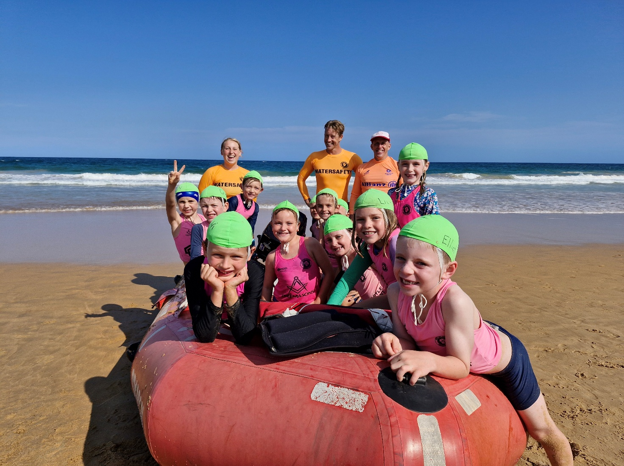

## Parents: How can I help?

Nippers is volunteer run! There are so many ways to be involved as a parent at Nippers! You do not need to have had surf lifesaving experience. You only need to ask…

One thing we can tell you for certain: the more you get involved, the more your child and you will enjoy Nippers. It is one of the few kids’ sports where the whole family can have a great morning together at the beach.

At Shelly Beach, we strongly encourage **all families** to have one parent with either their Age Manager award, Surf Rescue Certificate or Bronze Medallion.

## Volunteer checklist

If you wish to actively help with Nippers activities on the beach, you’ll need to:

* be a current member of Shelly Beach SLSC; and
* become an ‘Age Manager’ (course available); or
* hold a current Bronze Medallion; and
* provide us with your Working With Children Check (WWCC).

We really welcome all offers of help, and most importantly it is a great way of meeting new people.

Some other ways you can help:

* Help set up the beach or pack away
* Help on the BBQ (walk up and offer anytime, there will be an age-group roster)
* Learn to be an official
* Help at Club Champs and Carnivals
* Help organise Nippers social events
* Become an Age Manager
* Fund raising
* Any other help and ideas welcome

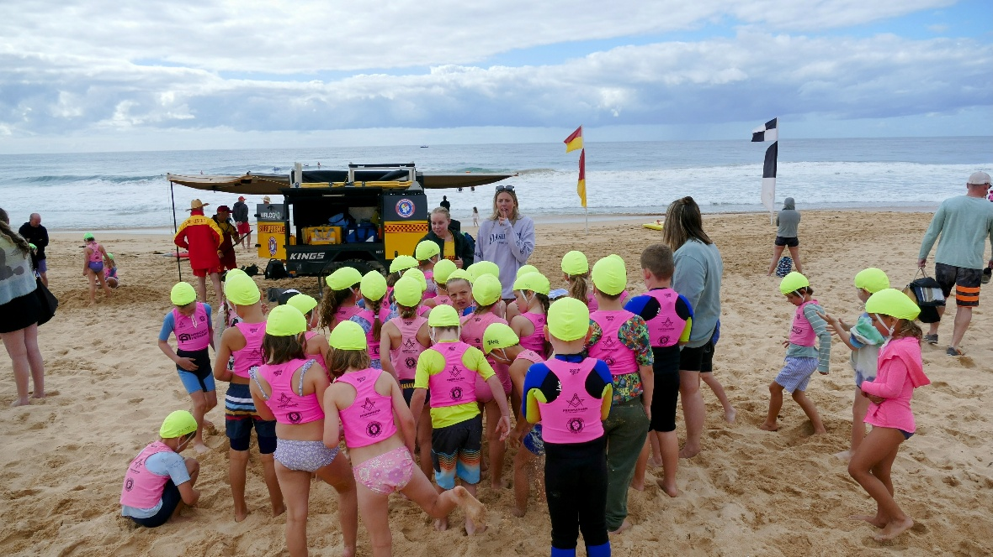

# Training and Carnivals

The Club is proud to offer our Nippers the opportunity to train and advance their skills and techniques both in the water (U9+) and on the sand (U8+). We offer different sessions to cater to all skills levels.

Board training sessions require water safety and all parents/carers who have a current Bronze Medallion are expected to bring their orange rashies and be prepared to get wet.

If there is insufficient water safety, the session may be cancelled or the number of kids in the water at any one time will be limited.

The training timetable will be posted on the [Shelly Beach Nippers](https://www.facebook.com/groups/2430938077141107) Facebook Group and we will also utilize the Heja App for these communications.

## Sand Training

Sand training is run at Shelly Beach and is aimed at Nippers who wish to improve their skills and race technique in beach sprints, beach relays and flags, as well as to improve their fitness.

Please request access to the [Shelly Beach Crumbed Cutlets](https://www.facebook.com/groups/crumbed.cutlets/) Facebook Group to see the training schedule and we will also utilize the Heja App for these communications.

## Water Training

Shelly Beach Water Training will be carried out throughout the season. Please request access to the [Shelly Beach Nipper Water Training](https://www.facebook.com/groups/277190310571142/) Facebook Group for the training schedule and we will also utilize the Heja App for these communications.

## Carnivals

Nipper Carnivals are run by many NSW Surf Clubs throughout the season. They provide a great opportunity to compete, gain experience, and have a fun morning meeting Nippers and families from other Clubs.

Carnival Entry is required in advance and there is a small entry fee to be paid. For entry please email nippers name and details to [enter@shellybeachsurfclub.com.au](mailto:enter@shellybeachsurfclub.com.au) or call the Team Manager prior to the entry cut-off. All Shelly Beach Nippers are encouraged and permitted to attend club-run carnivals. Branch and NSW State Championships are championship carnivals for top competitors who participate in regular training. The Club encourages all U8s to U14s Nippers to attend. Below are the ways Shelly Beach Nippers will be ready to attend carnivals:

1. Training sessions with qualified coaches Head Coaches Keaton Watts, Jacqui Eaton (Water), David Smith and Taliah Goy (Sand).
2. The Sunday Nipper program will give every Nipper confidence to enter the water and sand events.

## Parent involvement required at Carnivals

Carnivals are volunteer-run and the Club is obliged to send a quota of Water Safety and Officials corresponding to entry numbers. Nippers are not permitted to compete unless the Club has fulfilled its volunteer quotas.

Shelly Beach will encourage all parents to lend a hand, there are many training sessions available where you as a parent can get accreditation to be able to help in an official role, when helping at these carnivals it makes the whole process run very smooth with a lot of help.

“More hands make less work”

If your child intends to compete at Branch or at State, please start preparing early: enroll them in the required training and achieve your own relevant qualifications (Official or Water Safety). Neither can be done at the last minute.

If, for a particular Carnival, the Club’s quotas are not fulfilled and the Club is not able to

enter all interested Nippers, the Nippers of Officials and Water Safety will be prioritized.

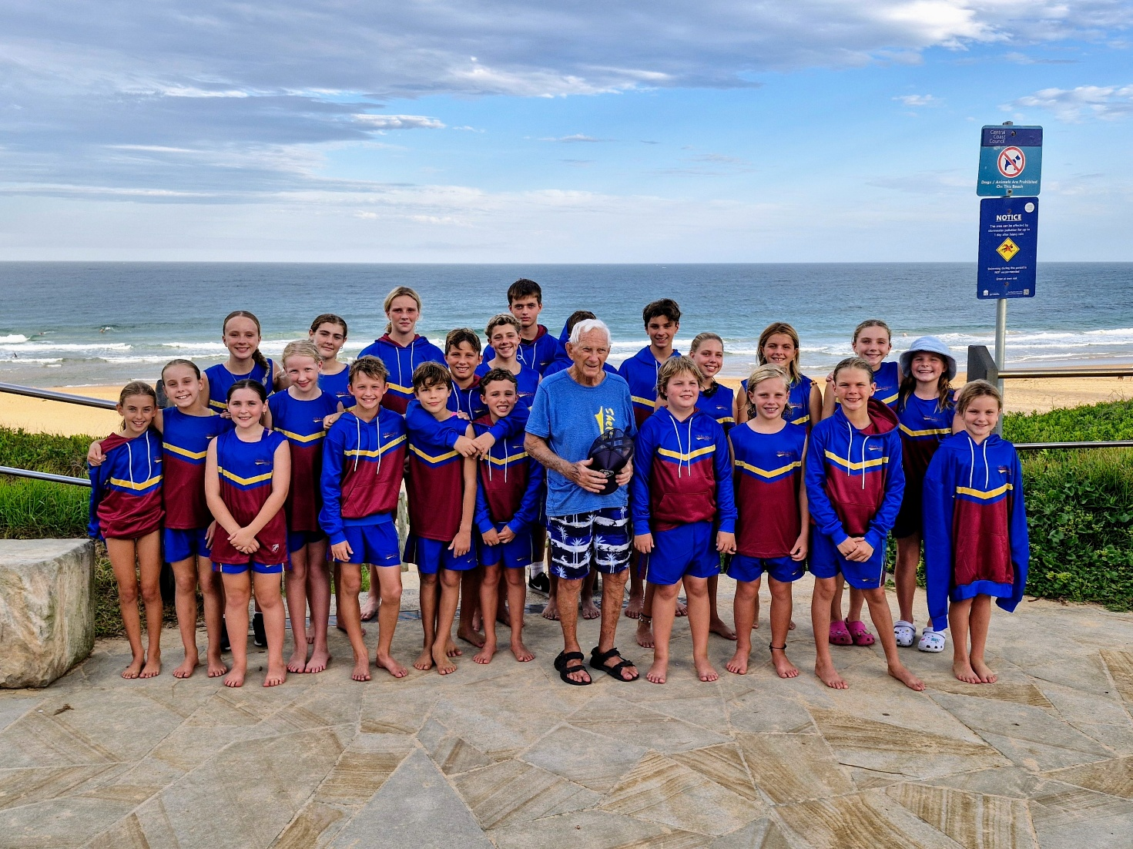

## SLSA Surf Education Awards

Shelly Beach SLSC takes surf education seriously, and it is one of the key reasons for being in Nippers. Surf education is based on a clearly defined structure and outcomes, as set by SLSA, to aid the children’s lifesaving development. During the season all Nippers are able to gain their respective Surf Education award for their age group through regular attendance at Nippers (Nippers who attend 75% of Nippers sessions prior to 31 December are eligible). Age managers will be teaching children to gain these awards.

**Listed below is a summary of the awards for each age group:**

Under 6 Surf Play 1

Under 7 Surf Play 2

Under 8 Surf Aware One

Under 9 Surf Aware Two

Under 10 Surf Safe One

Under 11 Surf Safe Two

Under 12 Surf Smart One

Under 13 Surf Smart Two

Under 14 Surf Rescue Certificate (SRC)

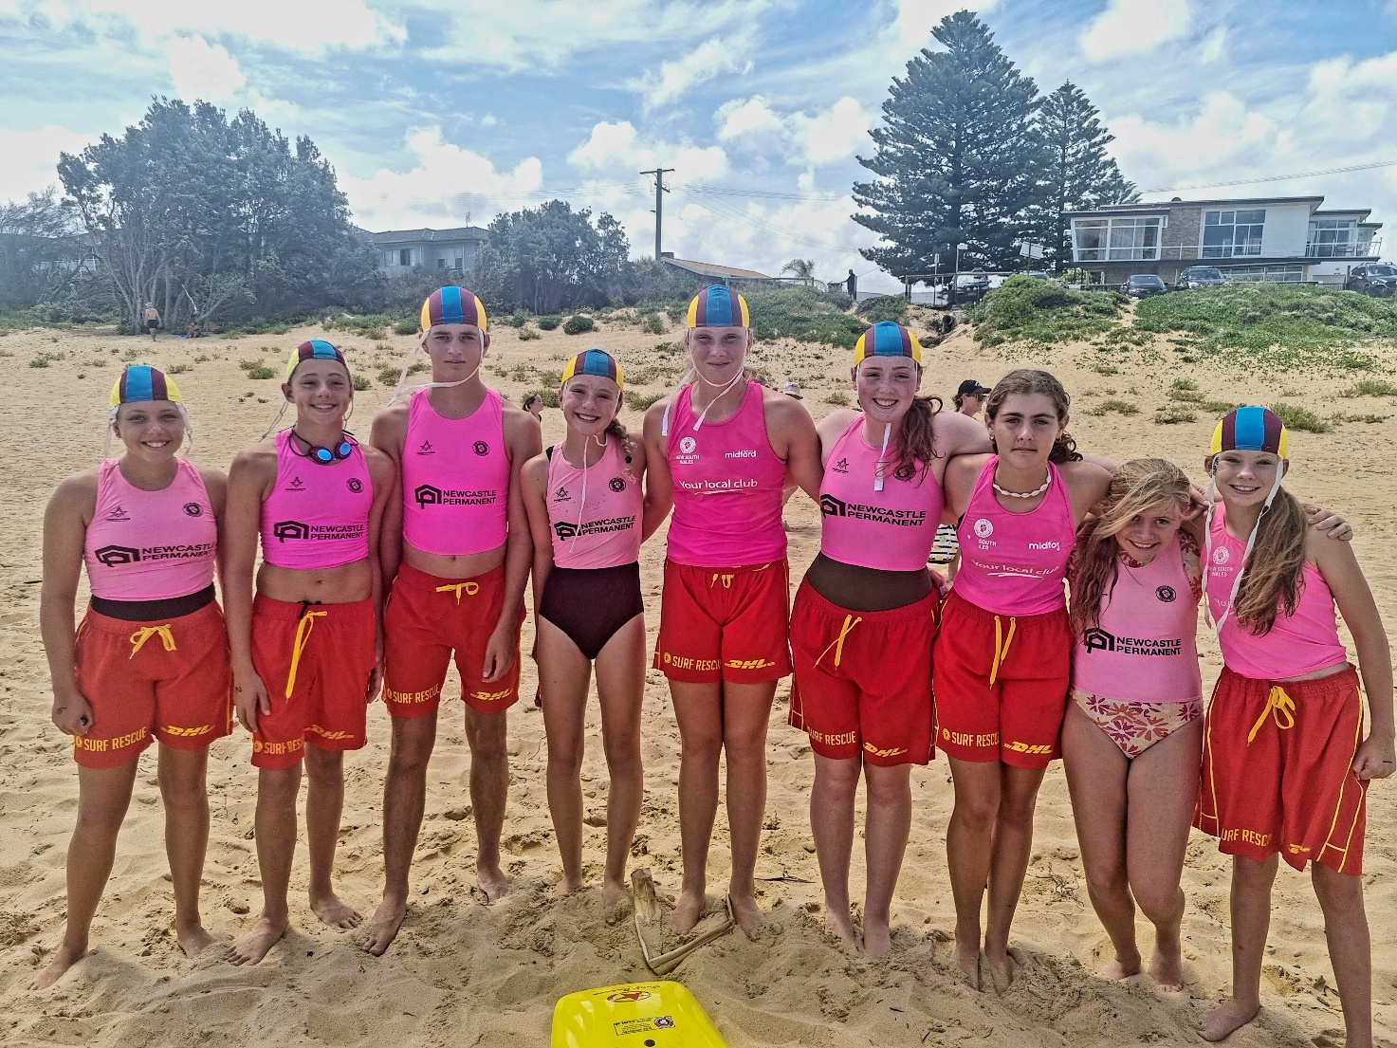

# Safety: always our first priority

**Safety is our first priority in all activities conducted by the Shelly Beach SLSC. Safety extends to safety on the beach, in the water and the protection of all children.**

## Safety in the Water

The Head of Water Safety will liaise with the Shelly Beach Lifesavers and the Patrol Captain each Sunday. The lifesavers will decide if the surf conditions are suitable to conduct activities. The Head of Water Safety or the Patrol Captain may cease activities if conditions become unsafe.

The guidelines for Water Safety are laid down by SLSA and must be adhered to by all. The IRB (Inflatable Rescue Boat) or “Rubber Duckie” must be present during all water events and it is imperative that we have the required number of qualified Water Safety people in the water. No water activity can commence if we don’t have the required number of Water Safety. Remember if you are Water Safety, you must wear the orange rash vest. and orange cap and sign in as Water Safety via your Nipper’s attendance roll.

|  |
| --- |
| No Water Safety parents = no water activities |

## Safety out of the water

If you are assisting with Nippers and are over the age of 18 you must be a current member of the Club. This is an SLSA requirement so that the Club is covered for insurance purposes. It is a requirement that at least one parent becomes a member of the Shelly Beach Surf Club (financial member).

All Age Managers, Age Assistants and Water Safety must hold a current Working With Children Check and send the number to [office@shellybeachsurfclub.com.au](mailto:office@shellybeachsurfclub.com.au).

This is free as a volunteer and can be obtained here: <https://www.service.nsw.gov.au/transaction/apply-working-children-check>

The club takes child protection seriously; any form of child abuse will not be tolerated and any serious cases will be reported to authorities.

## Nipper parents’ code of conduct

* Do not force an unwilling child to participate.
* Children are involved for their enjoyment, not yours.
* Encourage children to play by the rules.
* Encourage the effort as being as important as the result.
* Work towards improving skills and sportsmanship.
* Do not yell or abuse a child for making a mistake.
* Recognise and encourage good play or efforts.
* Respect the efforts of all volunteers: Age Managers, Age Assistants, Trainers, Water Safety, Coaches and Officials. They are not there to be abused or harassed. They are doing their best for your children.
* When at carnivals treat the Officials, and carnival organisers with respect. If unhappy with a decision, launch a formal protest.

## Nippers’ code of conduct

* Participate to enjoy the sport.
* Follow the rules.
* Control your temper and be a good sport.
* Treat other participants as you like to be treated.
* Encourage all in your team.
* Listen to your Age Managers, Age Assistants, Trainers, Water Safety, Coaches and Officials.
* Respect the decision of officials at carnivals.

# Club Championships and Awards

## Successful completion of the Preliminary and Ocean / Competition Proficiency Swim is required to compete in any Club Championship days and the Perpetual Ironperson event. Events are run under SLSA’s Surf Sports Manual (and any subsequent Bulletins and Circulars).

Attendance is a criteria in order to be eligible for certain awards. Nippers who attend a junior carnival in club colours (competing or some other club duty) will still qualify for that day’s attendance. An attendance exemption may be granted in exceptional circumstances, please contact the JAC President prior to the relevant event to apply for consideration.

## Club Championships

Club Championship days will be held during the season. All Nippers are encouraged to compete in these friendly races. These events go towards the Club Age Champion Awards but also help to prepare our Nippers for a competitive environment and give great life skills experience. Points will be allocated as per the table below and consist of the following events:

|  |  |
| --- | --- |
| **U8s** | Flags, Sprint & Wade |
| **U9 – U14** | Flags, Sprint, Swim & Board |

|  |  |
| --- | --- |
| **PLACE** | **POINTS PER EVENT** |
| First place | 6 |
| Second place | 5 |
| Third place | 4 |
| Fourth place | 3 |
| Fifth place | 2 |
| Sixth place | 1 |
| All others who finish the event | 1 |

The Club Championship days are run for ages U8 – U14 however a normal Nippers session will be run for the U6 & U7 age groups. These will be advertised once scheduled.

Points will be accumulated with the highest number of points scored becoming the overall winner.

A minimum of 50% attendance from the date of joining Shelly Beach Surf Club is required for eligibility to compete.

If due to conditions a Club Championship Day is cancelled and unable to be rescheduled, the result will be determined from any Club Championship Day held. All competitors must complete each event unaided in order to be eligible for points allocation. Where a Club Championship Day is only partially completed, only those who attended that day may participate in the remaining events of the Championships when rescheduled.

All completed events will be included in calculating Club Champs. If any particular sand or water event is not completed in either round, then points from the same event in the earlier/later round that was completed will be mirrored.

Great consideration and debate has gone into choosing our dates for Club Championships and we have tried to take into account other sports that may conflict but the dates we have chosen are final and will not be moved due to other sporting commitments of a few Nippers.

**Ironperson & Perpetual Awards**

# A minimum of 70% attendance from the date of joining Shelly Beach Surf Club is required to be eligible for the Ironperson and other Perpetual Awards.

# The Ironperson is a separate title to Club Age Champions and will only be run once with winners determined by their results on the day this is run, typically at the conclusion of a Club Championship Day but this will be communicated with advance notice.

Ironperson Perpetual Awards are awarded for the following categories:

* Sub-Junior Ironperson – U9s and U10s combined, male and female
* Junior Ironperson – U11s and U12s combined, male and female
* Senior Ironperson – U13s, male and female
* Club Ironperson – U14s, male and female

## Perpetual Awards

# The Club has a number of Perpetual Awards for Nippers each year, such as most improved, most consistent performance etc. Nominations will be sought towards the end of the season along with their Award criteria.

Upon the close of nominations, a meeting will be held soon after to discuss the nominees and their eligibility. This meeting should include, but not limited to, at least 1 Age Manager per age group, Rookie Co-Ordinator, JAC Executive, JAC Registrar, President and Coaches. Following this meeting, a closed meeting will take place to vote on the Award recipients. This closed meeting will include the JAC Executive, JAC Registrar and President.

## 100% Attendance Award

The 100% Attendance Award will be provided for all who achieve 100% attendance at Nipper events (must complete 2 events weekly).

## Age Group Awards

A minimum of 50% attendance from the date of joining Shelly Beach Surf Club is required to be eligible for Age Group Awards.

Any nippers unable to attain the 50% attendance requirement may submit an exemption in writing to the JAC for consideration for valid reasons.

# Proficiency Swims

### All Nippers from age groups U6-U14 must pass a proficiency swim and skills evaluation each season in order to participate at Nippers. This is a SLSA requirement and needs to be signed off by a designated club representative or your child’s swim coach.

Shelly Beach Nippers Committee members will be running preliminary evaluations over selected weekends prior to the beginning of the season, please see the calendar on the Shelly Beach SLSC website. Alternatively, if your child attends swim lessons or squad a form can be completed by your child coach and returned to [jac@shellybeachsurfclub.com.au.](mailto:jac@shellybeachsurfclub.com.au)

If you are concerned that your child may not pass the proficiencies, we suggest a practice run at swimming lessons or at the pool. We understand that kids get nervous and may not always do their best – they are welcome to have another go at it if they don’t make it on the first attempt.

The ocean / competition proficiency swim (150-200m for U9-U14s who wish to compete) will take place on the first day of Nippers or when conditions allow. Ocean swims are untimed and involve a group swim from the beach and around set buoys with plenty of water safety on hand. Wetsuits are strongly recommended.

## Stage 1: U6, U7 and U8

## Stage 2: U9, U10, U11

## 

## Stage 3: U12, U13, U14

## 

## Ocean / Competition Swim

# 

# Additional Nippers Information

The Shelly Beach Surf Club website contains a wealth of general information regarding nippers. Please visit <https://shellybeachsurfclub.com.au/members/nippers/>

**Shelly Beach Club Calendar** - <https://shellybeachsurfclub.com.au/events/>

**Surf Life Saving Central Coast Branch Calendar** - <https://slscc.com.au/events/month/>

Any questions or suggestions please contact:

Scott Eaton

JAC (Junior Activities Chairperson)

Shelly Beach Surf Club

M: 0421 814 067

Email: [jac@shellybeachsurfclub.com.au](mailto:jac@shellybeachsurfclub.com.au)

# Junior Activities Committee

The Committee members that support the Nippers program are set out in the below table:

|  |  |  |  |
| --- | --- | --- | --- |
| **Junior Activities Committee**  **2024/2025** | | | |
| Junior Activities Chairperson | Scott Eaton | [Jac@shellybeachsurfclub.com.au](mailto:Jac@shellybeachsurfclub.com.au) | 0421 814 067 |
| Vice JAC Chairperson | Carly Hudson | [carlyneate@gmail.com](mailto:carlyneate@gmail.com) | 0432 236 798 |
| JAC Registrar | Taegen Le Brocq | [jnr-registrar_sbslsc@outlook.com](mailto:jnr-registrar_sbslsc@outlook.com) | 0434 535 001 |
| Social Secretary | Erika Napier | erina@hrblock.com.au | 0433 489 363 |
| Water Captain | Rebecca Binns | [beckbinns@gmail.com](mailto:beckbinns@gmail.com) | 0401 023 879 |
| Beach Captain | David Smith |  |  |
| Team Manager | Jacqui Eaton |  |  |
| Carnival Entries | Jeanette Wright |  |  |
| Club Champs Points | Elinor Hardaker |  |  |
| Surf Education Coordinator | Carole Luntungan |  |  |
| Uniform Officer | Lorena Fernandez Collazo | [shellybeachuniform@icloud.com](mailto:shellybeachuniform@icloud.com) | 0470 650 179 |
| Child Protection Officer | Kim Burns  Craig Goy | [kimmy555@gmail.com](mailto:kimmy555@gmail.com) | 0414 965 556 |
| March Past Coordinator | Carlee McKay | [carlee_0404@hotmail.com](mailto:carlee_0404@hotmail.com) | 0401 556 510 |
| Presentation Coordinator | Scott Eaton  Carly Hudson |  |  |
| Water Confidence Officer | Jacqui Eaton |  |  |
| Rookie Coordinator | Tom Radic | [tom.radic@twrm.com.au](mailto:tom.radic@twrm.com.au) | 0407 830 075 |
| Under 6’s Age Managers | Sierra Vuradin |  |  |
| Under 7’s Age Managers | Bastian Sigl  Charlotte Long |  |  |
| Under 8’s Age Managers | Georgia Ray  Tahlia Goy | [Georgiaray821@gmail.com](mailto:Georgiaray821@gmail.com) | 0402 332 313 |
| *Under 9’s Age Managers* | Keaton Watts  Kianna Goy  Abbie Burns | [Keaton.infinity@gmail.com](mailto:Keaton.infinity@gmail.com) | 0414 823 163 |
| *Under 10’s Age Managers* | Carly Hudson |  |  |
| *Under 11’s Age Managers* | Kim Burns  Jeremy Aoun | [kimmy555@gmail.com](mailto:kimmy555@gmail.com)  [Aussieplumbing1@gmail.com](mailto:Aussieplumbing1@gmail.com) | 0414 965 556  0421 694 088 |
| *Under 12’s Age Managers* | Lauren Hirst  Harry Kingsley  Mikaela Williams-Potts | [logs24@hotmail.com](mailto:office@shellybeachsurfclub.com.au) | 0450 909 274 |
| *Under 13’s Age Managers* | Sarah Long |  |  |
| *Under 14’s Age Managers* | Tom Radic  Carlee McKay | [tom.radic@twrm.com.au](mailto:sandyadams22@outlook.com)  [carlee.ferguson@health.nsw.gov.au](mailto:carlee.ferguson@health.nsw.gov.au) | 0407 830 075  0401 556 510 |
| *Coaches* | Keaton Watts  Jacqui Eaton  Georgia Ray  David Smith  Tahlia Goy |  |  |